PRINT HDFC AND ICICI BANK SUPPLIER PAYMENT REPORT

STEP 1 :

* Go to settings->company-> open company-> insert icici and hdfc bank logo

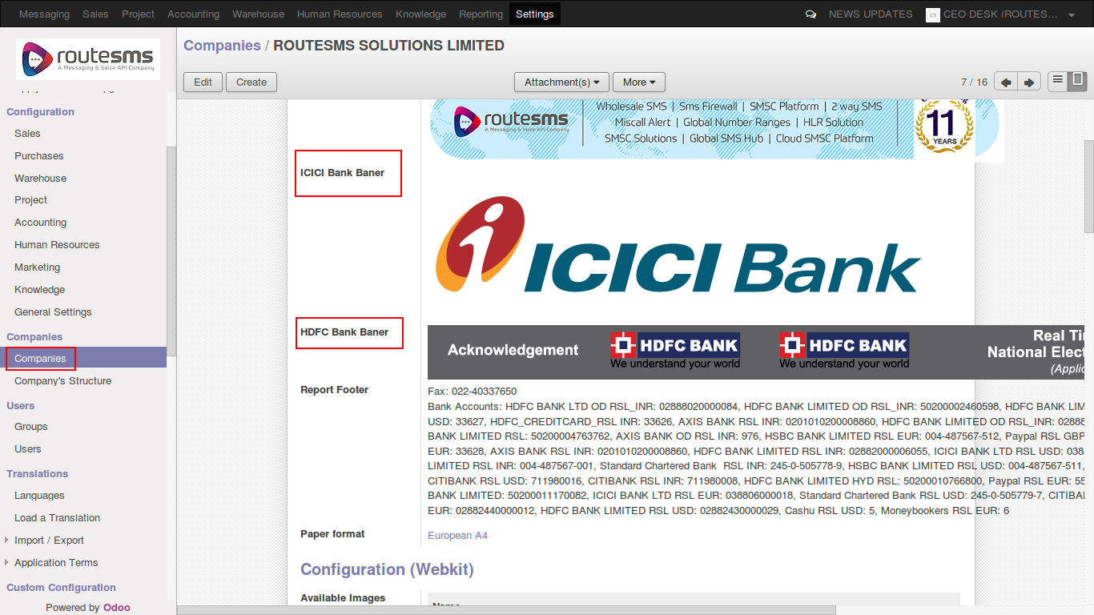

STEP 2:

* Go to Accounting-> supplier payement-> Open record-> click print button-> select report

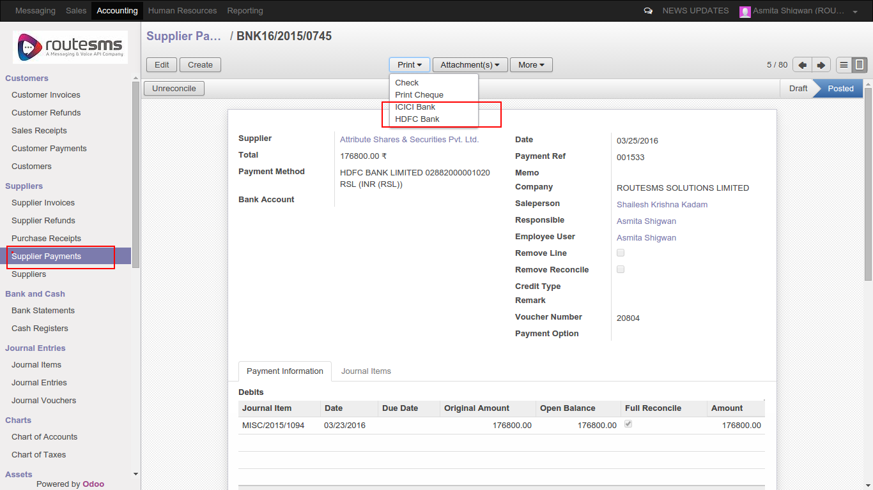

* ICICI Bank report preview

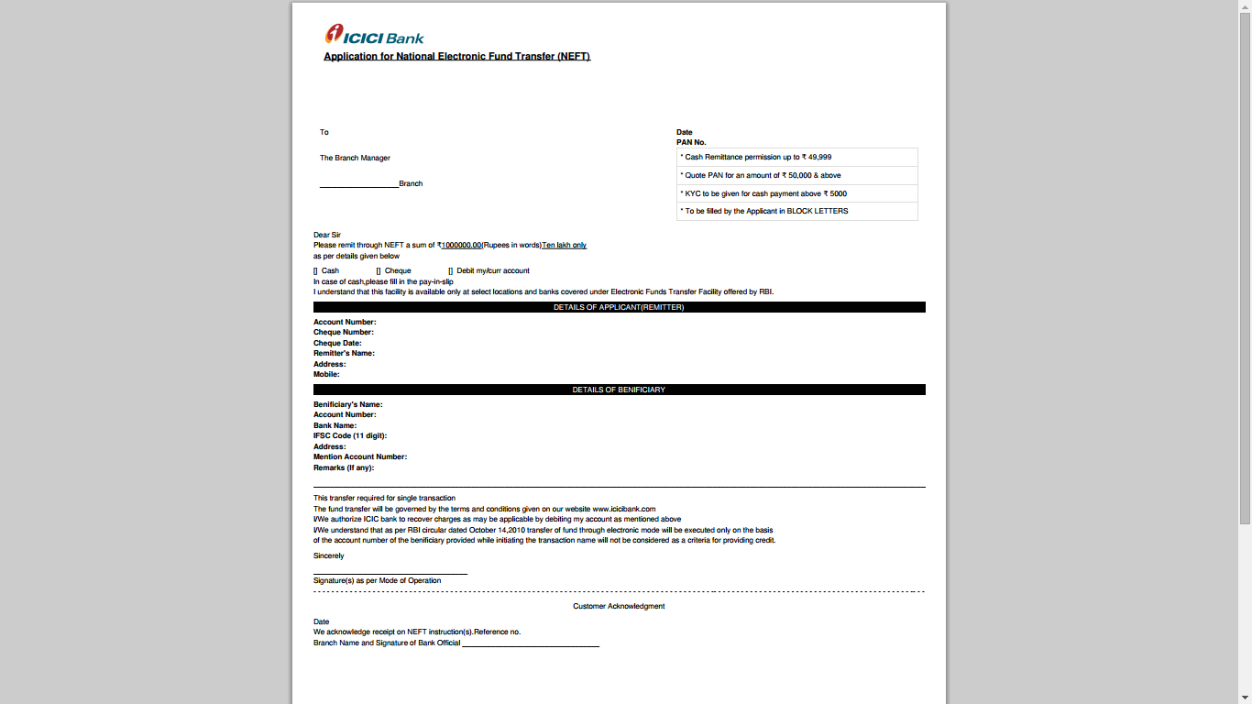

* HDFC bank preview

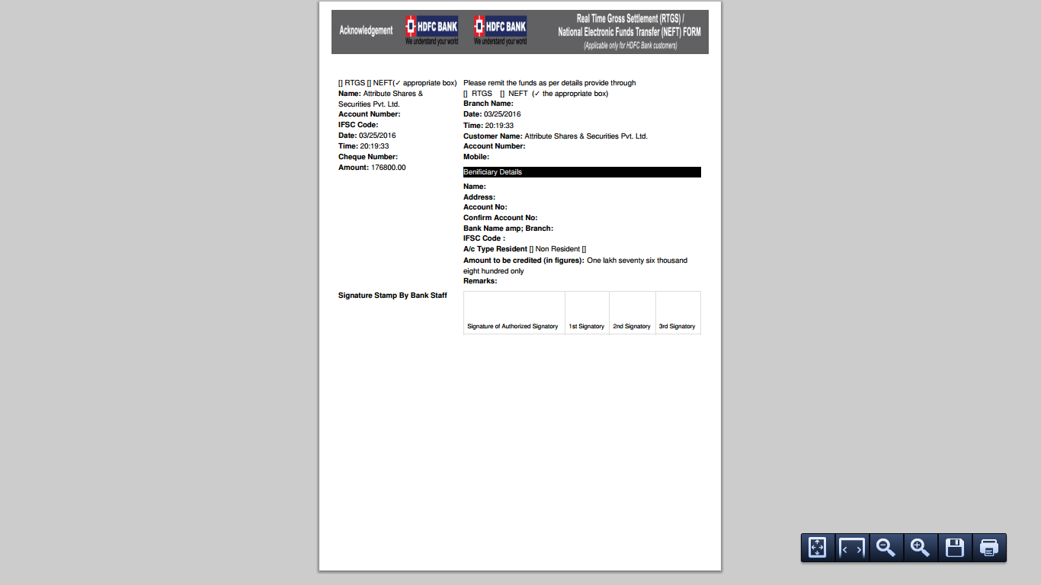

THANK YOU

